Test assignment - AskMeOffers Automatic Coupons Chrome Extension.

Link- <https://chromewebstore.google.com/detail/askmeoffers-automatic-cou/kmklnaljhcfcancckobnbafdhkbigfkk>.

Screenshots-

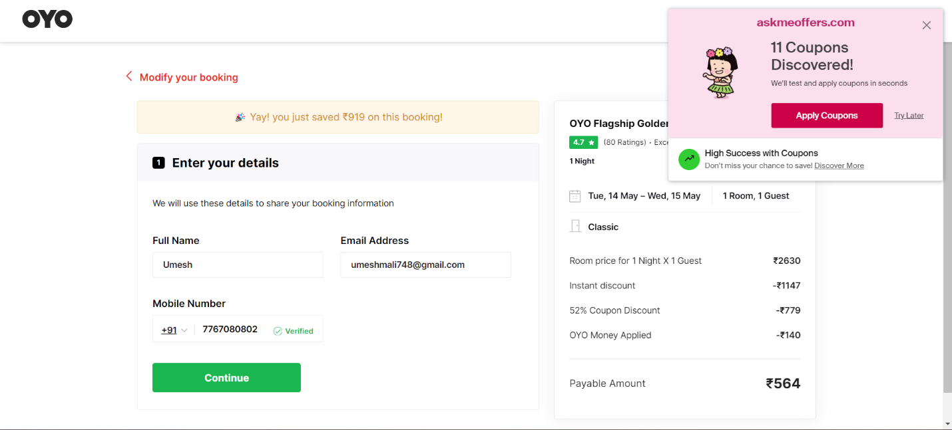



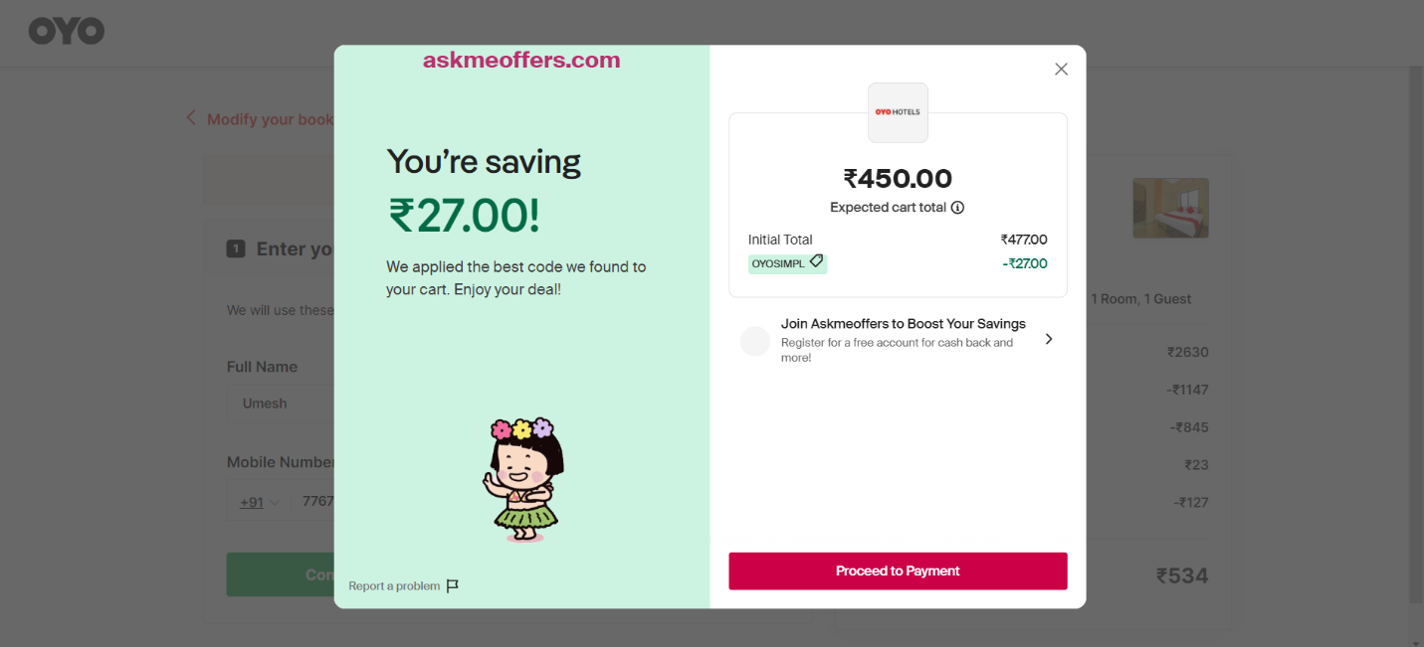

* **Feature Enhancement**

**Real-Time Price Comparison.**

**Enable users to find the best deals instantly.**

**Expand filters for amenities, budget, and ratings.**

**Integrate with loyalty programs for rewards.**

**Integrate social sharing and review features.**

**Implement timely notifications for changes.**

**Improve keyboard navigation and screen reader support.**

**Improve extension responsiveness and stability.**

* **Error Resolution**

1. **When attempting to apply a discount code during checkout, the extension fails to recognize valid codes.**

**Actual : This bug affects user experience and may lead to frustration and abandonment of the booking process.**

**Expected : Investigate the discount code validation logic and ensure compatibility with OYO Rooms' system.**

1. **Users encounter intermittent loading issues when browsing through accommodation options.**

**Actual: This performance-related bug disrupts the seamless browsing experience and may deter users from exploring further.**

**Expected: Conduct performance optimization to address loading delays and improve overall responsiveness.**

* **Performance Optimization**

**Pages and resources are taking longer than expected to load, leading to a subpar user experience.**

**Synchronous loading of resources is causing delays in page rendering and responsiveness.**

**Loading of non-critical resources and content upfront is contributing to prolonged loading times.**

**Lack of caching mechanisms leads to redundant data retrieval and processing.**

* **Documentation**

**Expected Result-**

**Verify that users can successfully browse accommodations, apply discounts, and complete bookings without encountering errors.**

**Actual Result-**

**During functionality testing, it was observed that applying discounts sometimes resulted in errors, with the discount not being applied correctly or not recognized by the system. Further investigation is needed to identify the root cause and implement a fix.**

* **Reporting**

**Accommodations browsing, discount application, and booking processes were generally successful.**

**However, issues were encountered with discount application, where discounts were not consistently applied or recognized by the system.**

Performance improvements-

**Further investigation is required to identify and address the root cause of the discount application issues.**

**Implement thorough testing of discount functionality across different scenarios to ensure consistent and reliable behavior.**

**Conduct additional rounds of testing to validate fixes and ensure overall system stability.**